Data Structures

Lecture No. 21

Reading Material

Data Structures and Algorithm Analysis in C++ Chapter. 4 4.4, 4.4.1

Summary
- AVL Tree Building Example
- Cases for Rotation

AVL Tree Building Example
This lecture is a sequel of the previous one in which we had briefly discussed about building an AVL tree. We had inserted three elements in the tree before coming to the end of the lecture. The discussion on the same example will continue in this lecture. Let’s see the tree’s figures below:

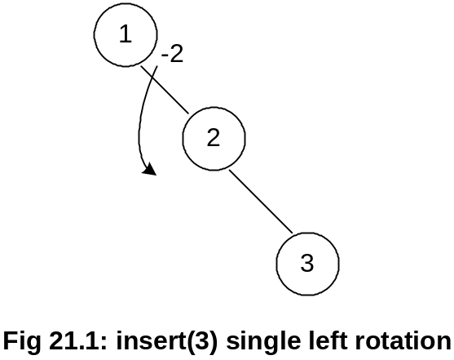

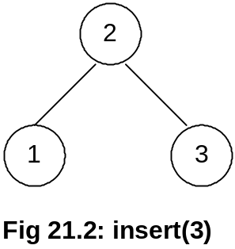
Node containing number 2 became the root node after the rotation of the node having number 1. Note the direction of rotation here.
Let’s insert few more nodes in the tree. We will build an AVL tree and rotate the node when required to fulfill the conditions of an AVL tree.
To insert a node containing number 4,we will, at first, compare the number inside the root node. The current root node is containing number 2. As 4 is greater than 2, it will take the right side of the root. In the right subtree of the root, there is the node containing number 3. As 4 is also greater than 3, it will become the right child of the node containing number 3.
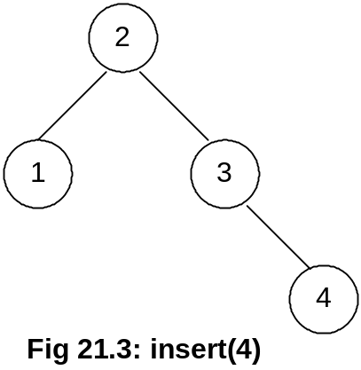
Once we insert a node in the tree, it is necessary to check its balance to see whether it is within AVL defined balance. If it is not so, then we have to rotate a node. The balance factor of the node containing number 4 is zero due to the absence of any left or right subtrees. Now, we see the balance factor of the node containing number 3. As it has no left child, but only right subtree, the balance factor is –1. The balance factor of the node containing number 1 is 0. For the node containing number 2, the height of the left subtree is 1 while that of the right subtree is 2. Therefore, the balance factor of the node containing number 2 is 1 – 2 = -1. So every node in the tree in fig. 21.3 has balance factor either 1 or less than that. You must be remembering that the condition for a tree to be an AVL tree, every node’s balance needs not to be zero necessarily. Rather, the tree will be called AVL tree, if the balance factor of each node in a tree is 0, 1 or –1. By the way, if the balance factor of each node inside the tree is 0, it will be a perfectly balanced tree.
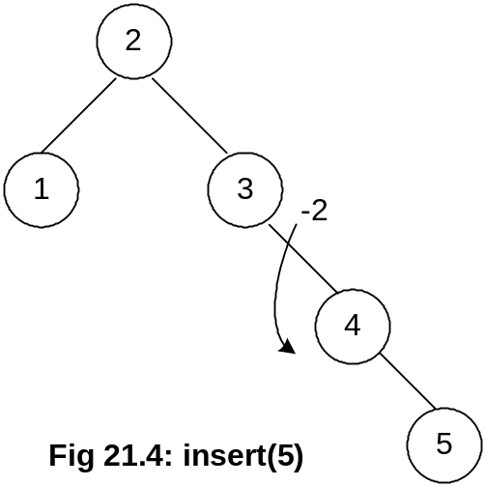
Next, we insert a node containing number 5 and see the balance factor of each node. The balance factor for the node containing 5 is 0. The balance factor for node containing 4 is –1 and for the node containing 3 is -2. The condition for AVL is not satisfied here for the node containing number 3, as its balance factor is –2. The rotation operation will be performed here as with the help of an arrow as shown in the above Fig 21.4. After rotating the node 3, the new tree will be as under:

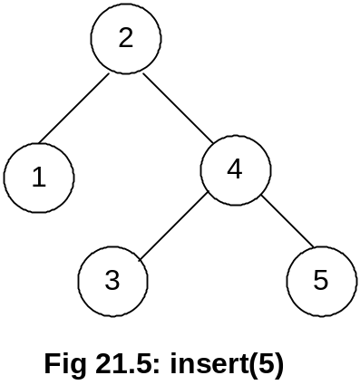

You see in the above figure that the node containing number 4 has become the right child of the node containing number 2. The node with number 3 has been rotated. It has become the left child of the node containing number 4. Now, the balance factor for different nodes containing numbers 5, 3 and 4 is 0. To get the balance factor for the node containing number 2, we see that the height of the left subtree containing number 2 is 1 while height of the right subtree is 2. So the balance factor of the node containing number 2 is –1. We saw that all the nodes in the tree above in Fig 21.5 fulfill the AVL tree condition.
If we traverse the tree Fig 21.5, in inorder tree traversal, we get:
1 2 3 4 5
Similarly, if we traverse the tree in inorder given in Fig 21.4 (the tree before we had rotated the node containing number 3), following will be the output.
1 2 3 4 5
In both the cases above, before and after rotation, we saw that the inorder traversal of trees gives the same result. Also the root (node containing number 2) remained the same.
See the Fig 21.4 above. Considering the inorder traversal, we could arrange the tree in such a manner that node 3 becomes the root of the tree, node 2 as the left child of node 3 and node 1 as the left child of the node 2. The output after traversing the changed tree in inorder will still produce the same result:
1 2 3 4 5

While building an AVL tree, we rotate a node immediately after finding that that the node is going out of balance. This ensures that tree does not become shallow and remains within the defined limit for an AVL tree.

Let’s insert another element 6 in the tree. The figure of the tree becomes:

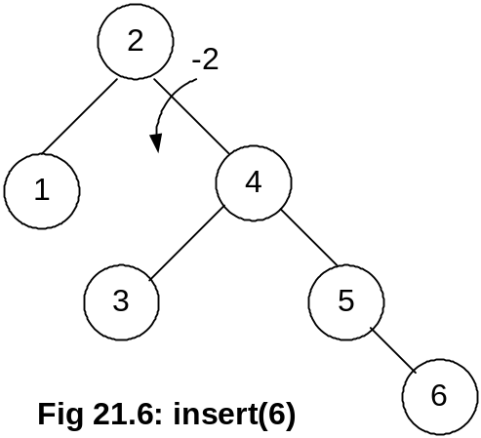

The newly inserted node 6 becomes the right child of the node 5. Usually, after the insertion of a node, we will find out the node factor for each node and rotate it immediately. This is carried out after finding the difference out of limit. The balance factor for the node 6 is 0, for node 5 is –1 and 0 for node 3. Node 4 has –1 balance factor and node 1 has 0. Finally, we check the balance factor of the root node, node 2, the left subtree’s height is 1 and the right subtree’s height is 3. Therefore, the balance factor for node 2 is –2, which necessitates the rotation of the root node 2. Have a look on the following figure to see how we have rotated the node 2.

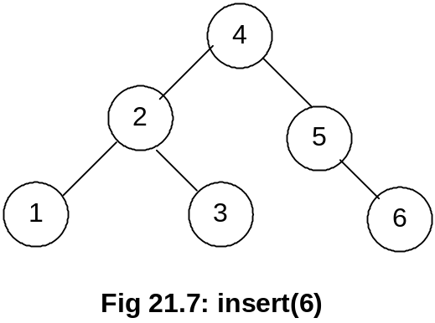

Now the node 4 has become the root of the tree. Node 2, which was the root node, has become the left child of node 4. Nodes 5 and 6 are still on their earlier places while remaining the right child and sub-child of node 4 respectively. However, the node 3, which was left child of node 4, has become the right child of node 2.
Now, let’s see the inorder traversal of this tree:
1 2 3 4 5 6

You are required to practice this inorder traversal. It is very important and the basic point of performing the rotation operation is to preserve the inorder traversal of the tree. There is another point to note here that in Binary Search Tree (BST), the root node remains the same (the node that is inserted first). But in an AVL tree, the root node keeps on changing.

In Fig 21.6: we had to traverse three links (node 2 to node 4 and then node 5) to reach the node 6. While after rotation, (in Fig 21.7), we have to traverse the two links (node 4 and 5) to reach the node 6. You can prove it mathematically that inside an AVL tree built of n items; you can search up to 1.44log₂n levels to find a node inside. After this maximum number of links traversal, a programmer will have success or failure, as 1.44log₂n is the maximum height of the AVL tree. Consider the BST case, where we had constructed a linked list. If we want to build a BST of these six numbers, a linked list structure is formed. In order to reach the node 6, we will have to traverse five links. In case of AVL tree, we had to traverse two links only.

Let’s add few more items in the AVL tree and see the rotations performed to maintain AVL characteristics of the tree.

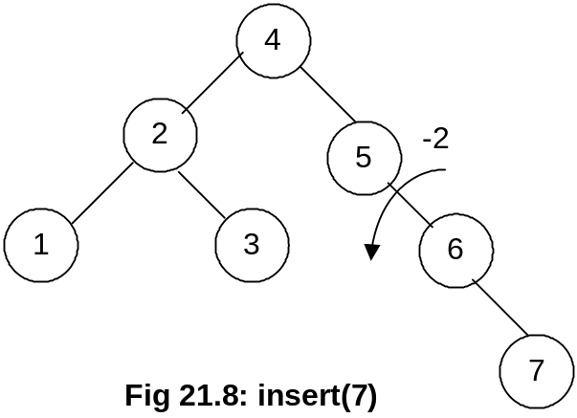

Node 7 is inserted as the right child of node 6. We start to see the balance factors of the nodes. The balance factors for node 7, 6 are 0 and –1 respectively. As the balance factor for node 5 is –2, the rotation will be performed on this node. After rotation, we get the tree as shown in the following figure.

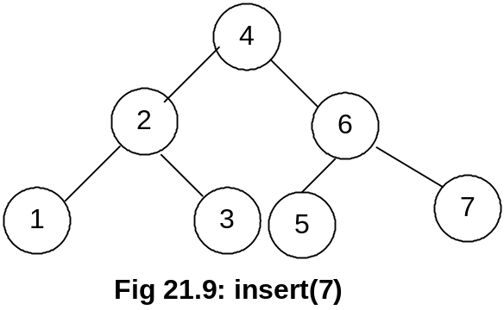

After the rotation, node 5 has become the left child of node 6. We can see in the Fig 21.9 that the tree has become the perfect binary tree. While writing our program, we will have to compute the balance factors of each node to know that the tree is a perfectly balanced binary tree. We find that balance factor for all nodes 7, 5, 3, 1, 6, 2 and 4 is 0. Therefore, we know that the tree is a perfect balanced tree. Let’ see the inorder traversal output here:
1 2 3 4 5 6 7
It is still in the same sequence and the number 7 has been added at the end.

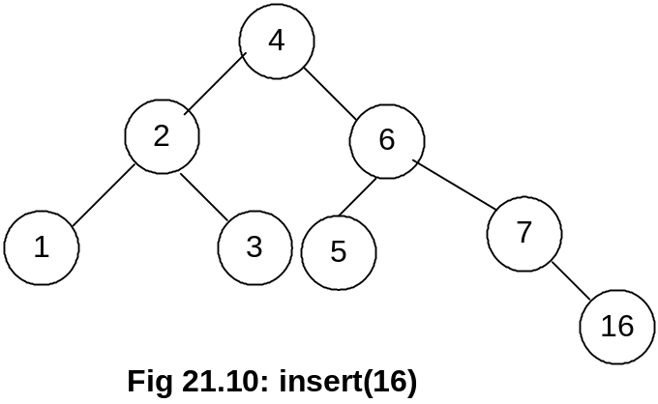

We have inserted a new node 16 in the tree as shown in the above Fig 21.10. This node has been added as the right child of the node 7. Now, let’s compute the balance factors for the nodes. The balance factor for nodes 16, 7, 5, 3, 1, 6, 2 and 4 is either 0 or –1. So this fulfills the condition of a tree to be an AVL. Let’s insert another node containing number 15 in this tree. The tree becomes as given in the figure below:

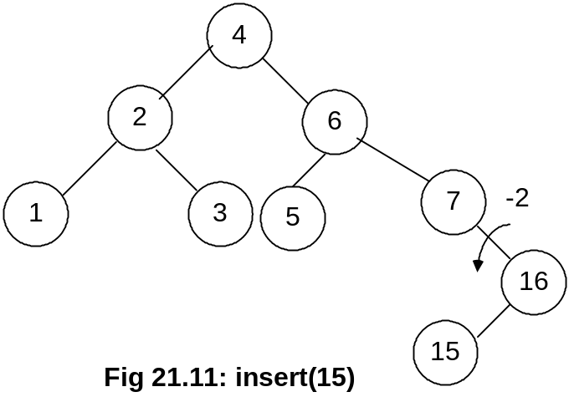

Next step is to find out the balance factor of each node. The factors for nodes 5 and 16 are 0 and 1 respectively. This is within limits of an AVL tree but the balance factor for node 7 is –2. As this is out of the limits of AVL, we will perform the rotation operation here. In the above diagram, you see the direction of rotation. After rotation, we have the following tree:

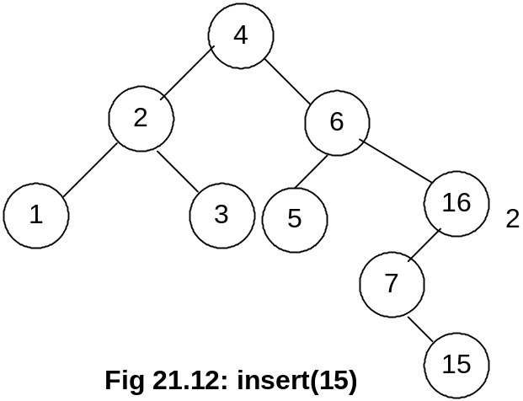

Node 7 has become the left child of node 16 while node 15 has attained the form of the right child of node 7. Now the balance factors for node 15, 7 and 16 are 0, -1 and 2 respectively. Note that the single rotation above when we rotated node 7 is not enough as our tree is still not an AVL one. This is a complex case that we had not encountered before in this example.

Cases of Rotation
The single rotation does not seem to restore the balance. We will re-visit the tree and rotations to identify the problem area. We will call the node that is to be rotated as α (node requires to be re-balanced). Since any node has at the most two children, and a height imbalance requires that α’s two sub-trees differ by two (or –2), the violation will occur in four cases:

1. An insertion into left subtree of the left child of α.
2. An insertion into right subtree of the left child of α.
3. An insertion into left subtree of the right child of α.
4. An insertion into right subtree of the right child of α.

The insertion occurs on the outside (i.e., left-left or right-right) in cases 1 and 4. Single rotation can fix the balance in cases 1 and 4.

Insertion occurs on the inside in cases 2 and 3 which a single rotation cannot fix.

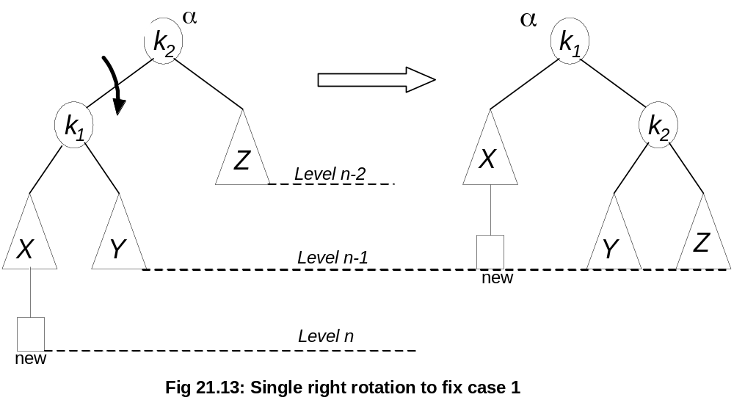

We have shown, single right notation to fix case 1. Two nodes k2 and k1 are shown in the figure, here k2 is the root node (and also the α node, k1 is its left child and Z shown in the triangle is its right child. The nodes X and Y are the left and right subtrees of the node k1. A new node is also shown below to the triangle of the node X, the exact position (whether this node will be right or left child of the node X) is not mentioned here. As the new node is inserted as a child of X that is why it is called an outside insertion, the insertion is called inside if the new node is inserted as a child of the node Y. This insertion falls in case 1 mentioned above, so by our definition above, single rotation should fix the balance. The k2 node has been rotated single time towards right to become the right child of k1 and Y has become the left child of k2. If we traverse the tree in inorder fashion, we will see that the output is same:
X k1 Y k2 Z

Consider the the figure below:
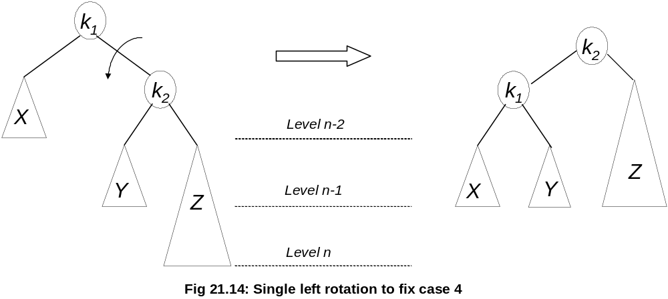In this figure (Fig 21.14), the new node has been inserted as a child node of Z, that is why it is shown in bigger size covering the next level. Now this is an example of case 4 because the new node is inserted below the right subtree of the right child of the root node (α). One rotation towards should make it balanced within limits of AVL tree. The figure on the right is after rotation the node k1 one time towards left. This time node Y has become the right child node of the node k1.
In our function of insertion in our code, we will do insertion, will compute the balance factors for nodes and make rotations.
Now, we will see the cases 2 and 3, these are not resolved by a single rotation.

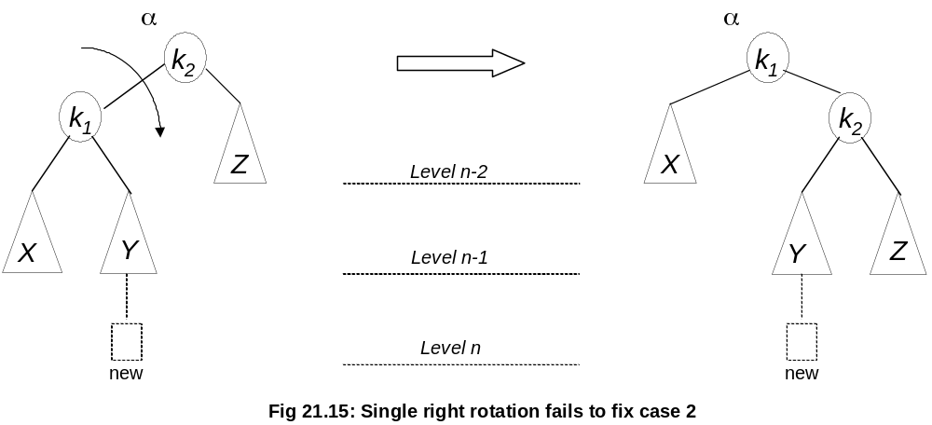

We see here that the new node is inserted below the node Y. This is an inside insertion. The balance factor for the node k2 became 2. We make single rotation by making right rotation on the node k2 as shown in the figure on the right. We compute the balance factor for k1, which is –2. So the tree is still not within the limits of AVL tree. Primarily the reason for this failure is the node Y subtree, which is unchanged even after making one rotation. It changes its parent node but its subtree remains intact. We will cover the double rotation in the next lecture.

It is very important that you study the examples given in your text book and try to practice the concepts rigorously.

